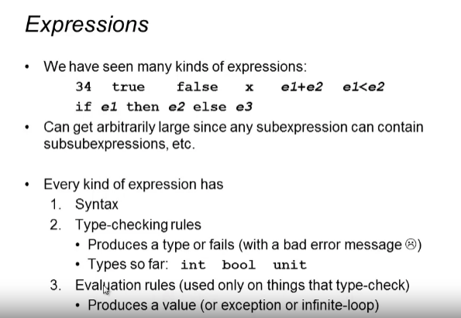

Constants

* Final results of expressions

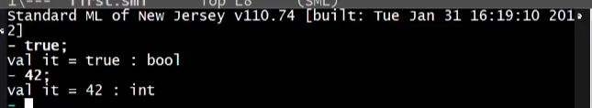

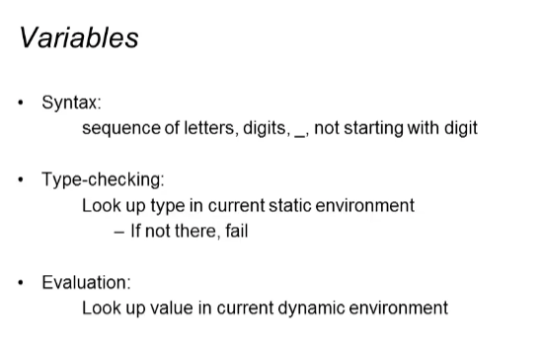

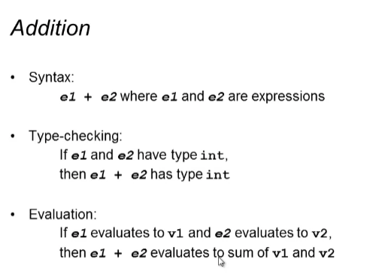

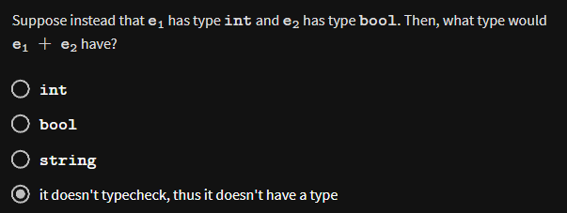



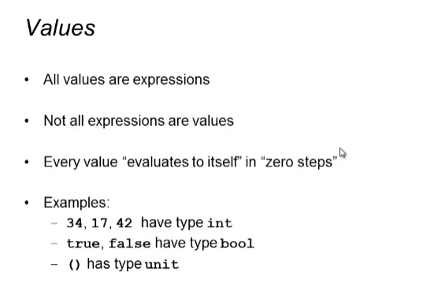

() -> when we use the “use” command

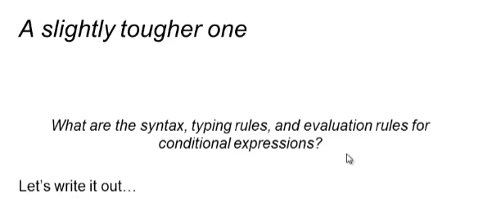

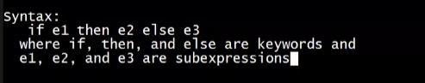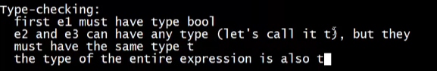

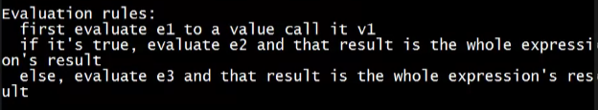

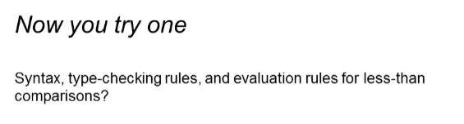

Syntax: e1 < e2 where e1 and e2 are expressions

Type-checking:

* e1 and e2 must be of the same type int
* result of the expression must be bool

Evaluation:

1. Evaluate e1 to v1 and e2 to v2
2. Produce false if v2 is less than v1 otherwise true